Lab-4 (1) Static and Default Routes(E)

Step 5: Verify the basic configurations.
Q4-1.1.Paste the screenshot of the created topology.
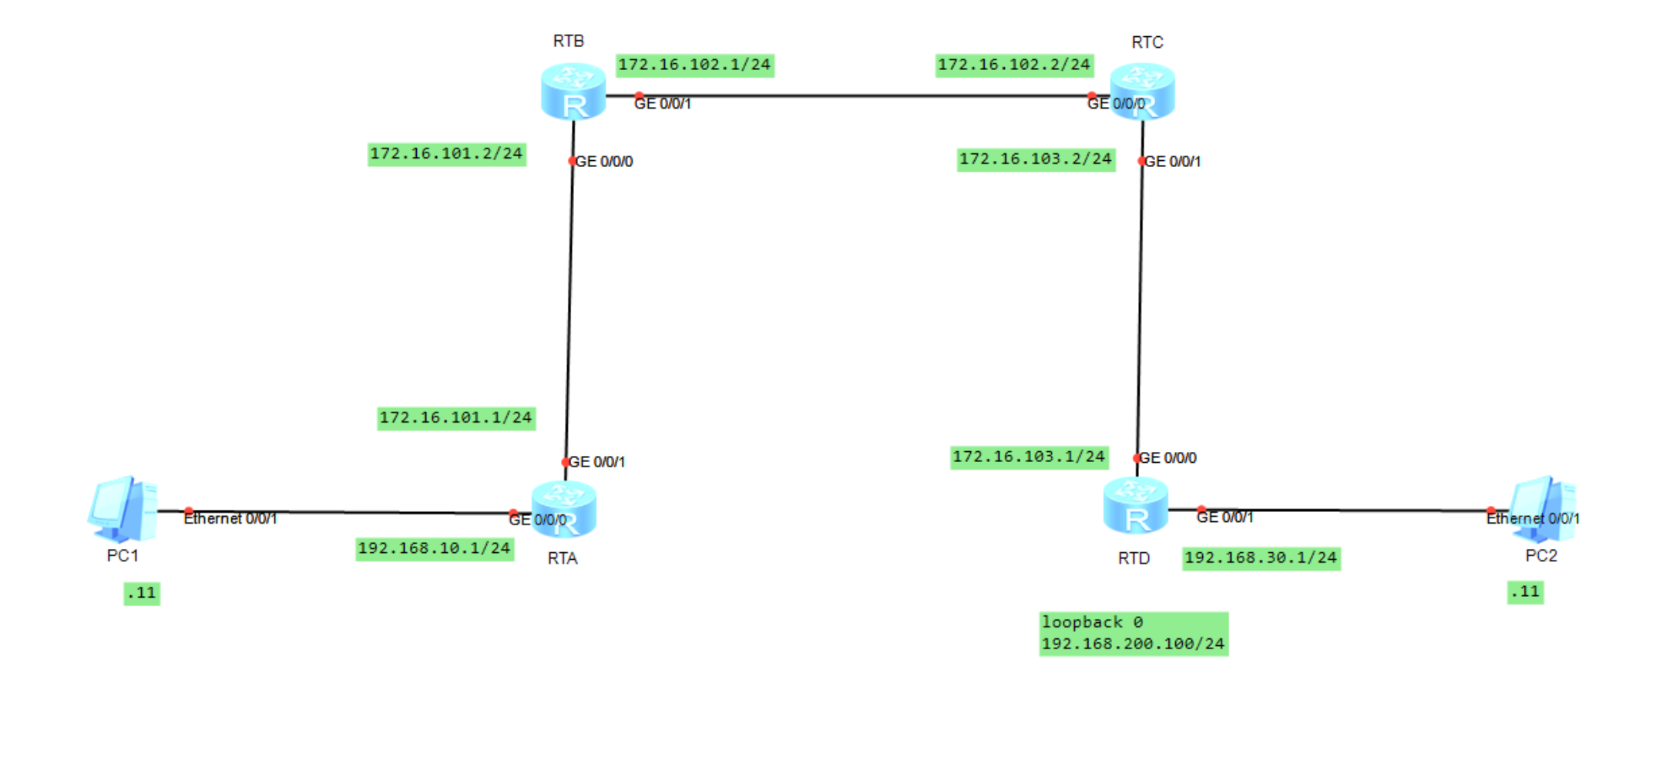
Q4-1.2. Paste the screenshot of the IP routing table on the router RTA.
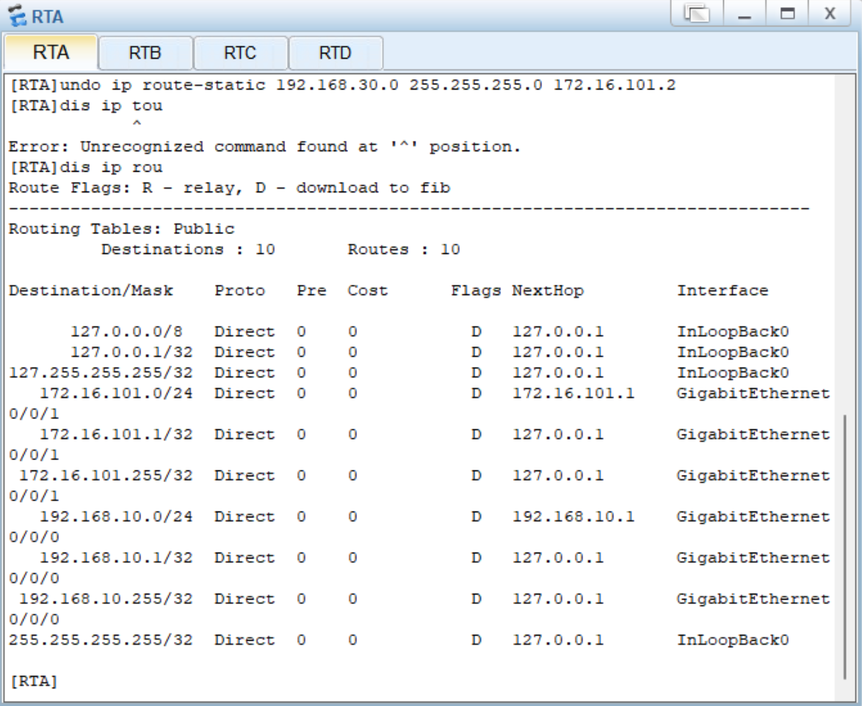
Q4-1.3. Paste the screenshot of the IP routing table on the router RTB.
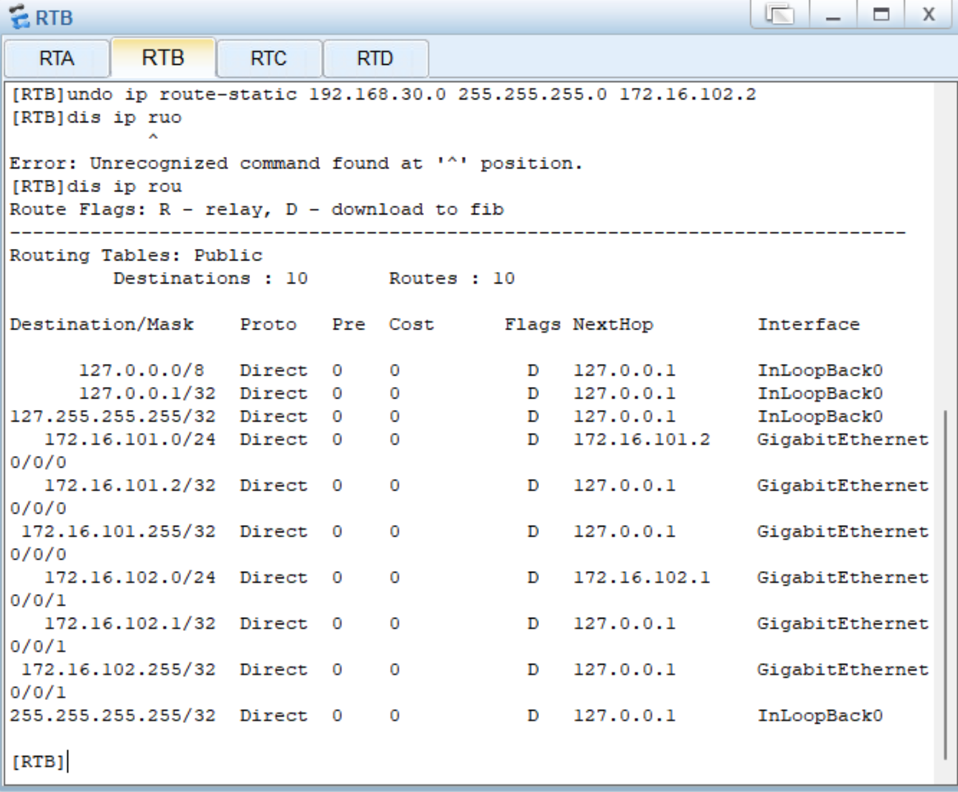
Q4-1.4. Paste the screenshot of the IP routing table on the router RTC.
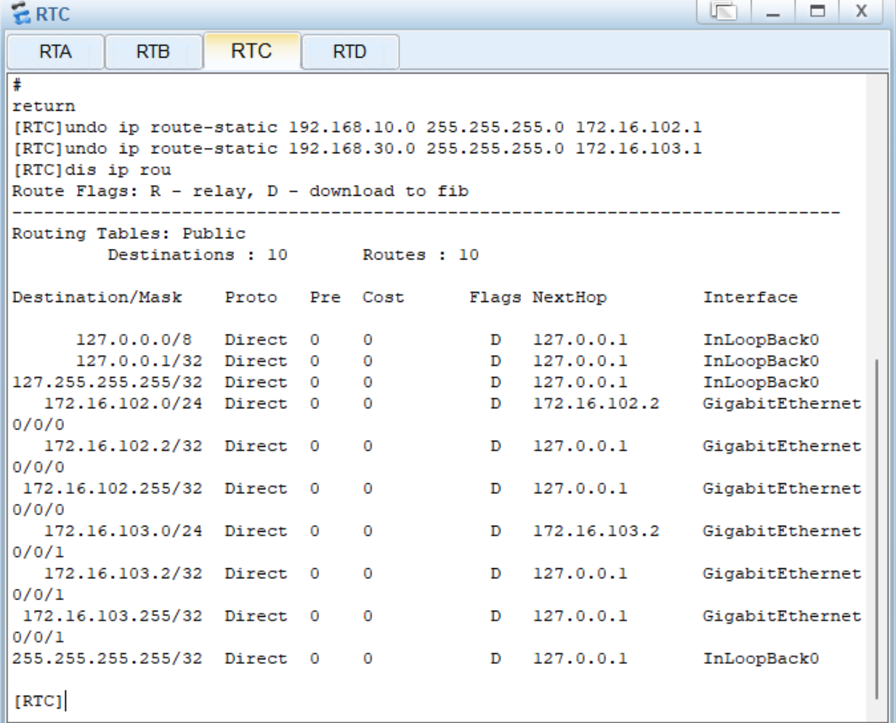
Q4-1.5. Paste the screenshot of the IP routing table on the router RTD.
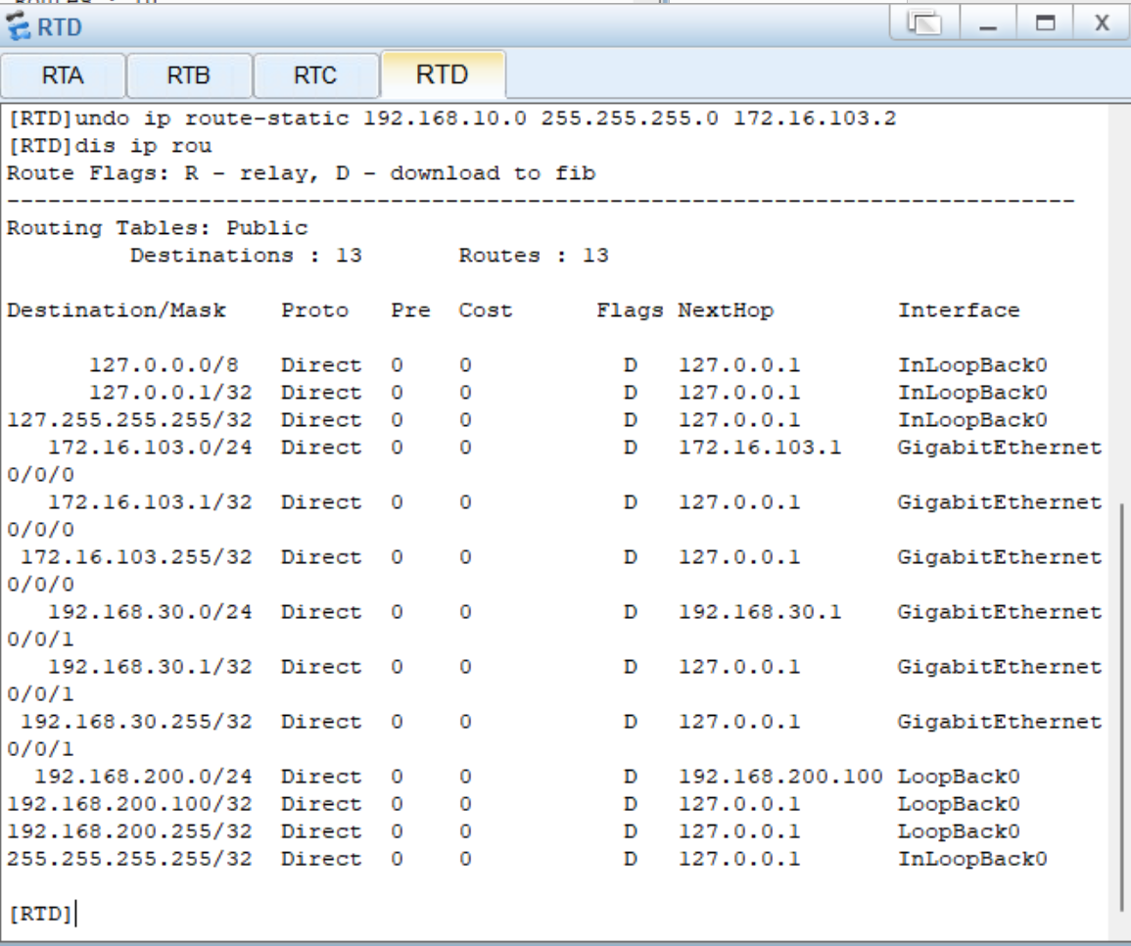
Q4-1.6. Can PC-10-1 and PC-30-1 ping each other? Please paste the screenshot of the ping result.
NO, they can’t.
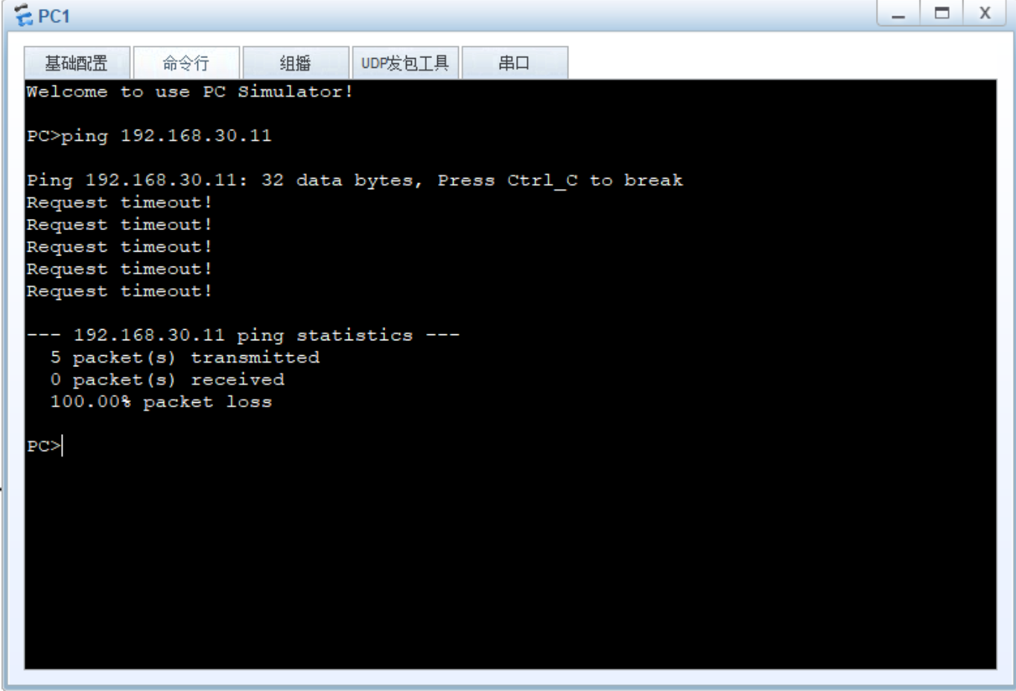
Q4-1.7. Can PC-30-1 and loopback 0 on RTD ping each other? Please paste the screenshot of the ping result.
YES, they can.
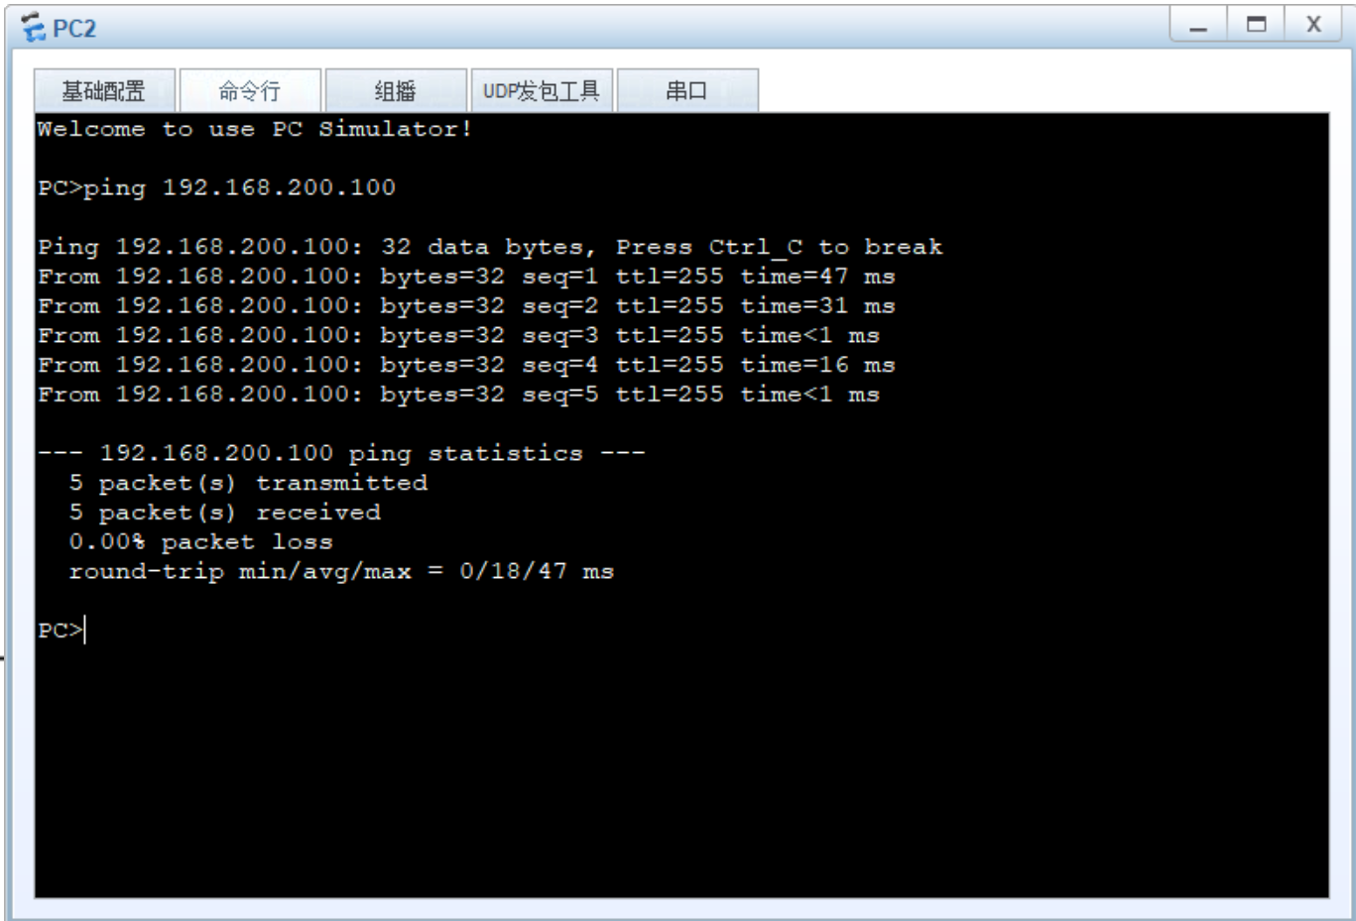
Q4-1.8. Can PC-10-1 and loopback 0 on RTD ping each other? Please paste the screenshot of the ping result.
NO, they can’t.
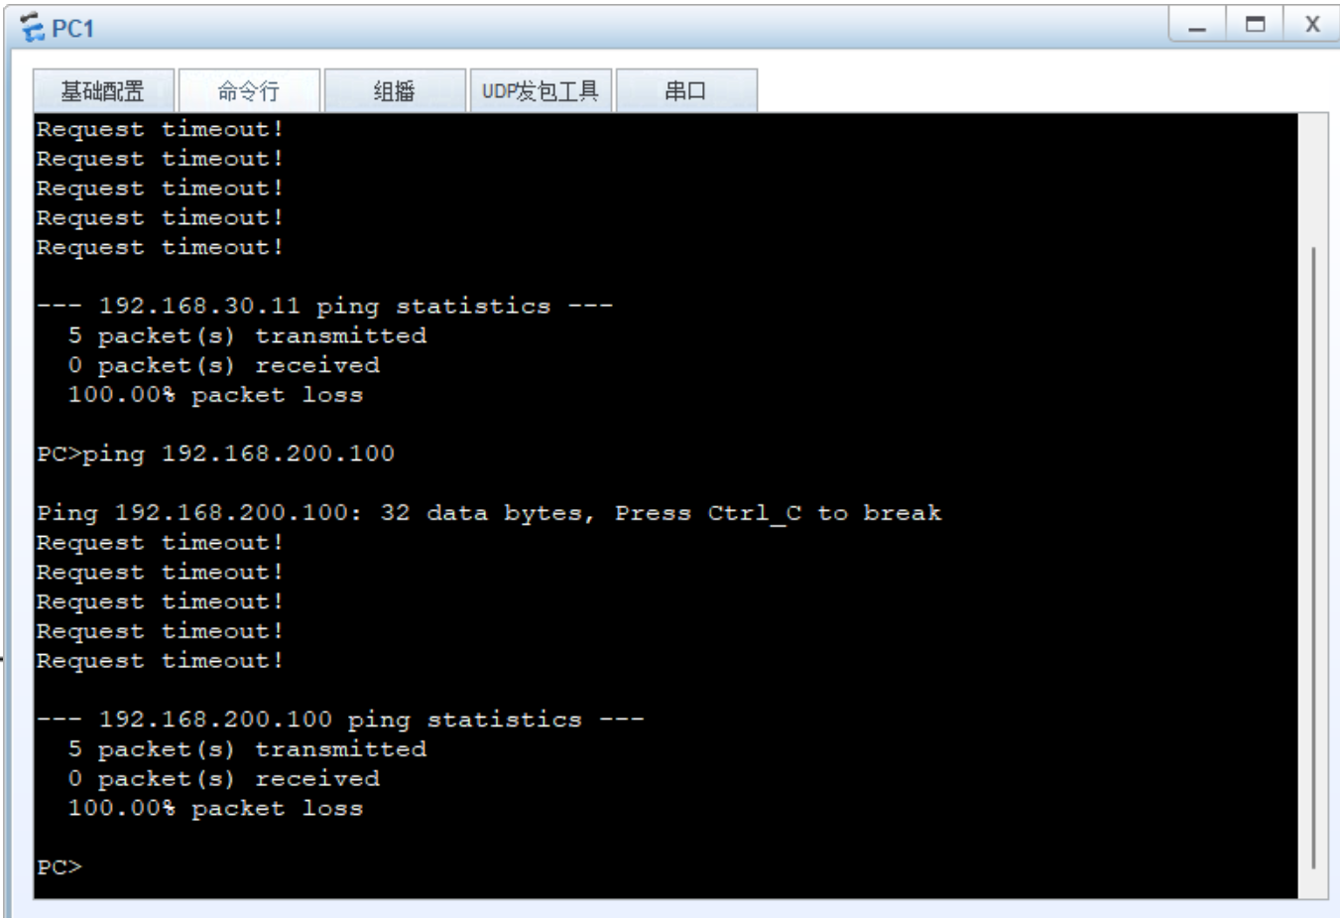

Step 7: Verify the static route configurations.
Q4-1.9. Paste the screenshot of the IP routing table on the router RTA.
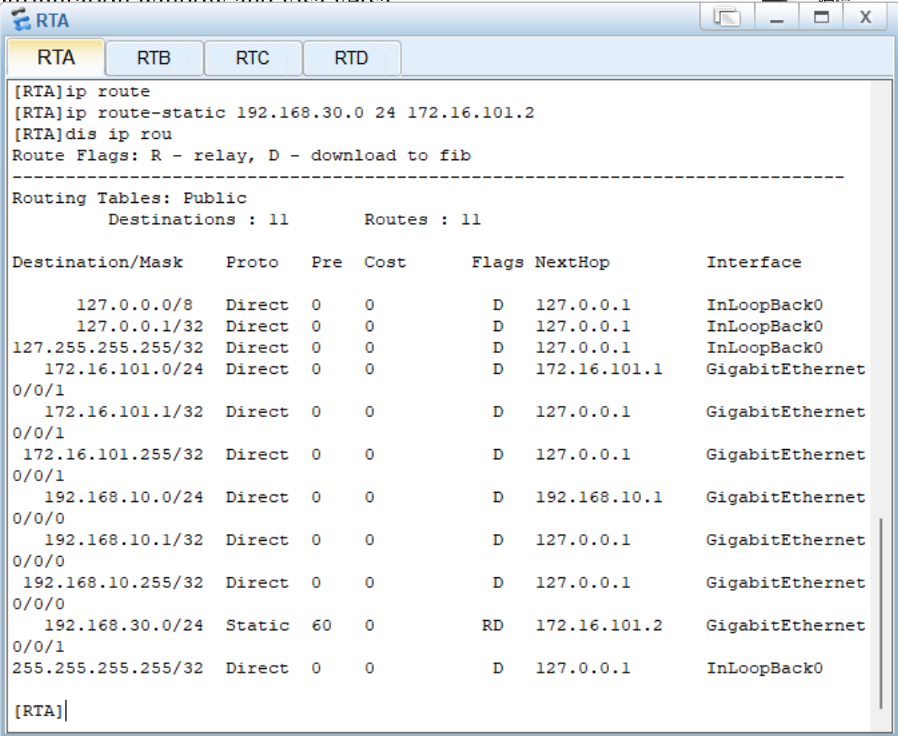

Q4-1.10. Paste the screenshot of the IP routing table on the router RTB.
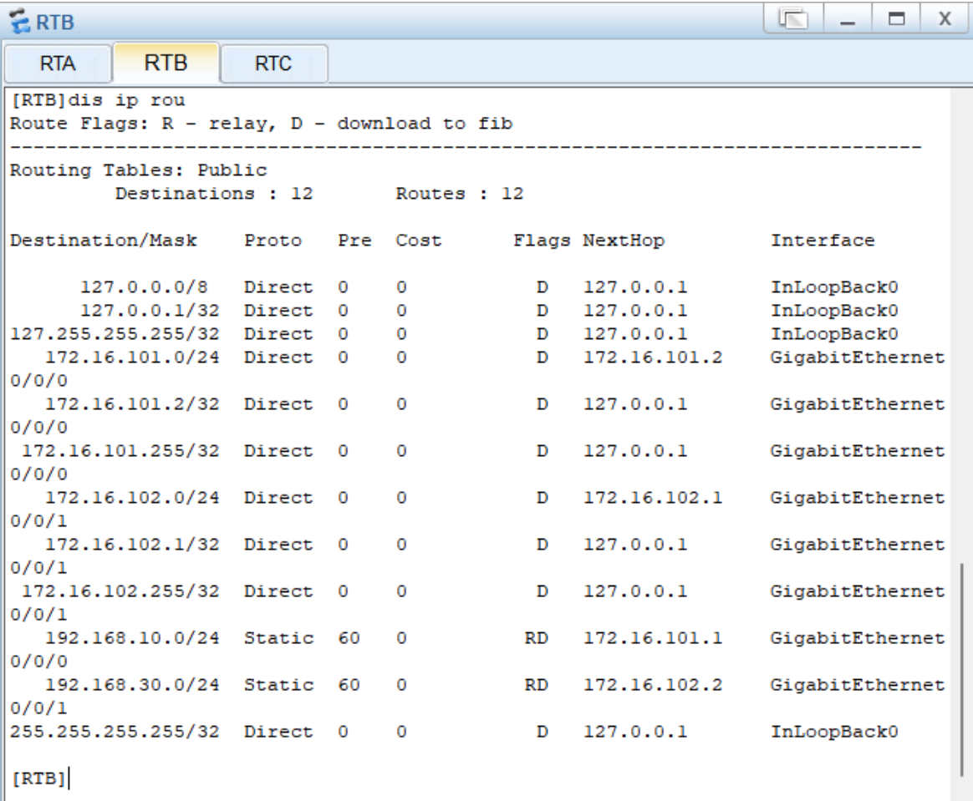

Q4-1.11. Paste the screenshot of the IP routing table on the router RTC.
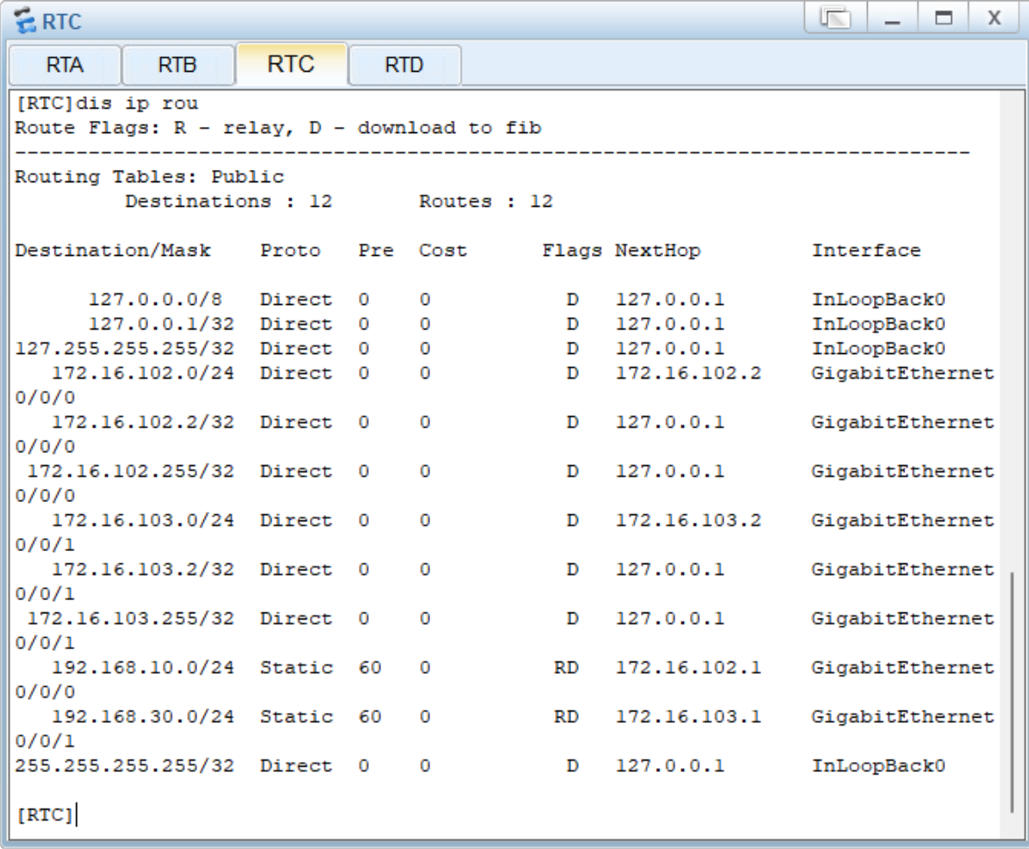
Q4-1.12. Paste the screenshot of the IP routing table on the router RTD.
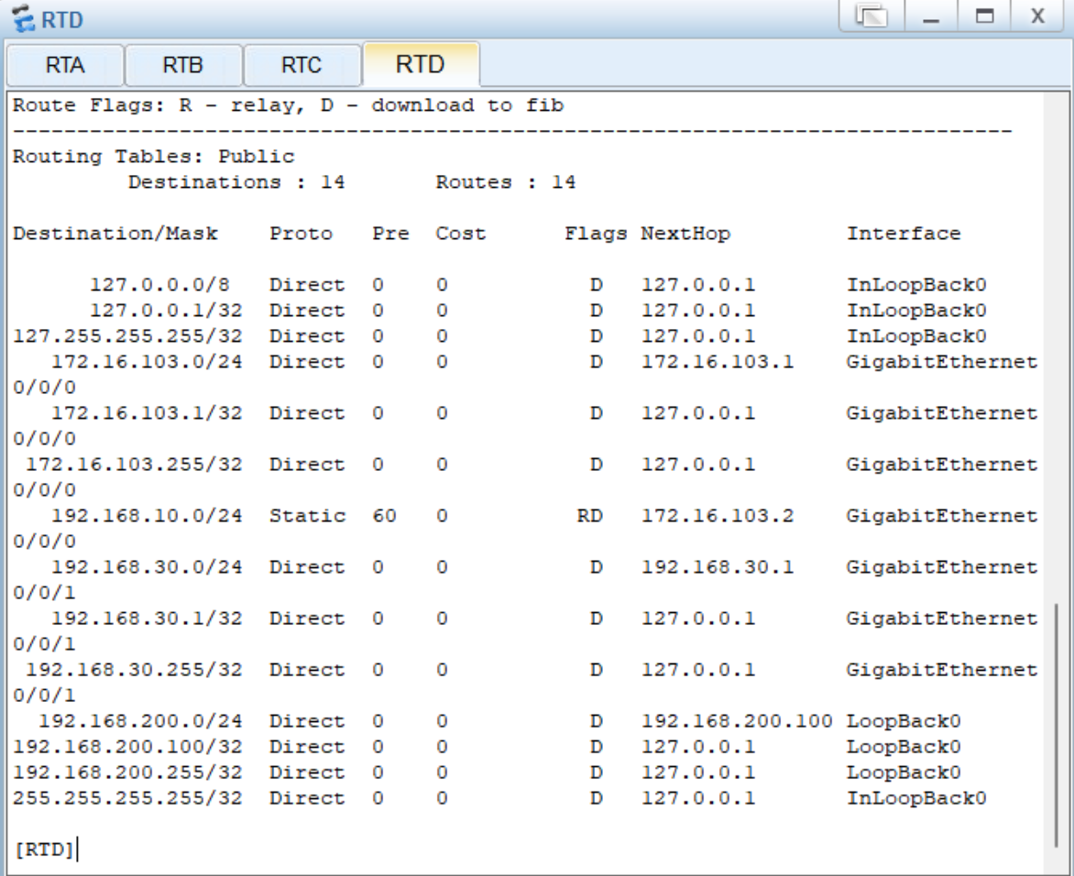
Q4-1.13. Can PC-10-1 and PC-30-1 ping each other? Please paste the screenshot of the ping result.
YES, they can.
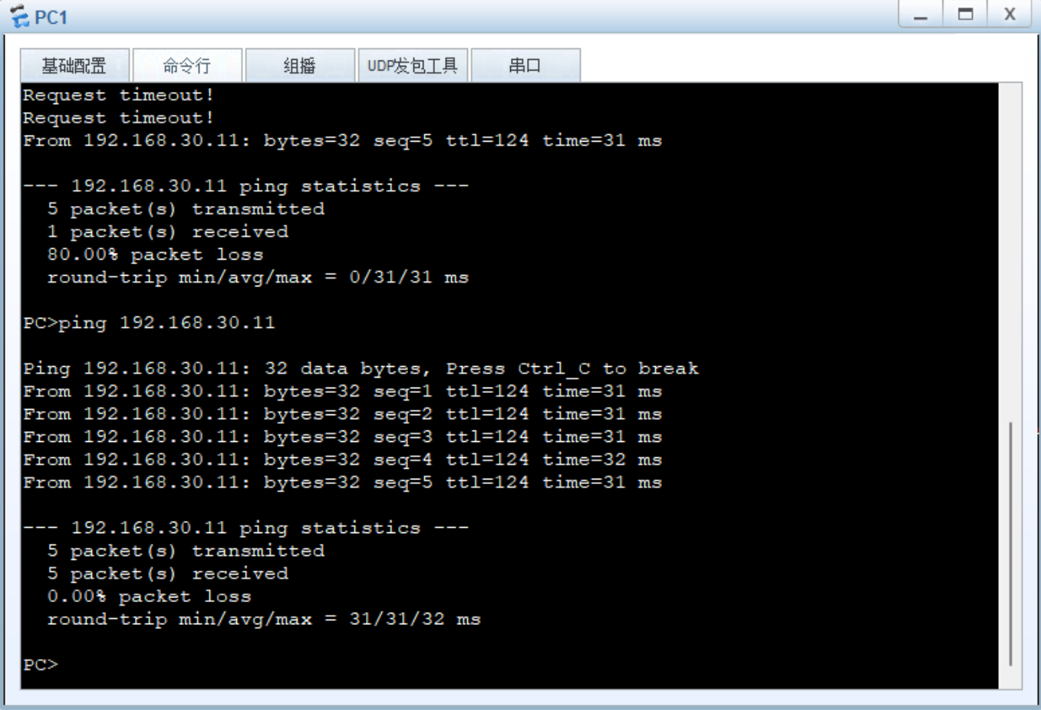
Q4-1.14. Can PC-10-1 and loopback 0 on RTD ping each other? Please paste the screenshot of the ping result. If they cannot ping each other, please explain why.

Cannot be pinged because there is no route for the 192.168.200.0/24 CIDR block
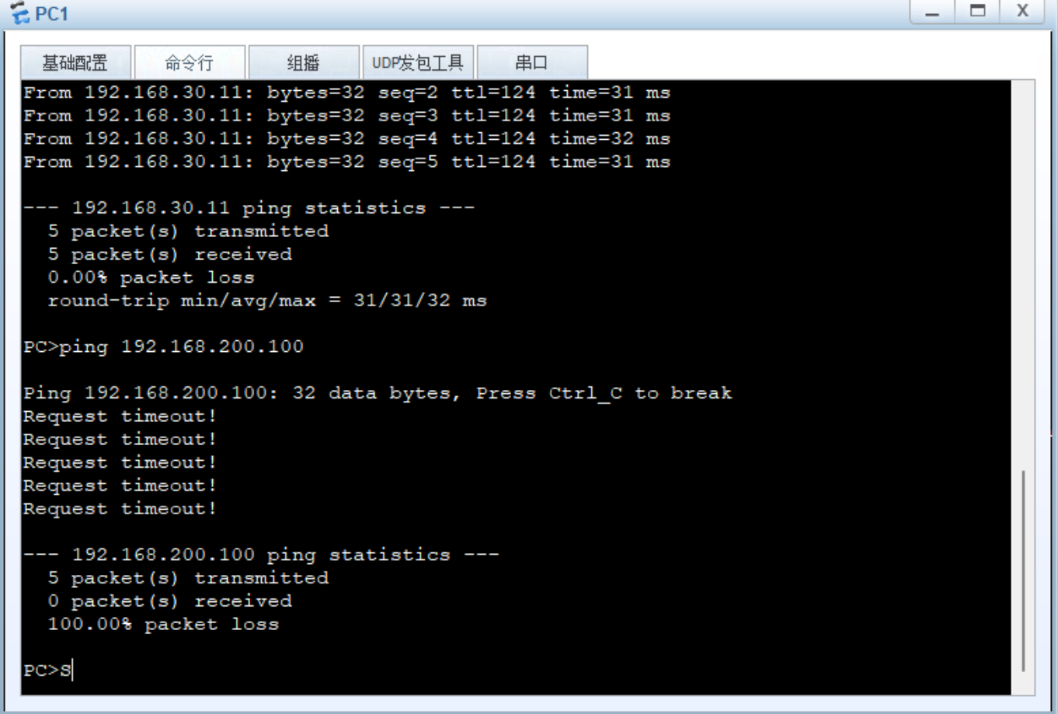
Q4-1.15. Please paste the screenshot of the result of command “tracert 192.168.30.11” issued from PC-10-1.
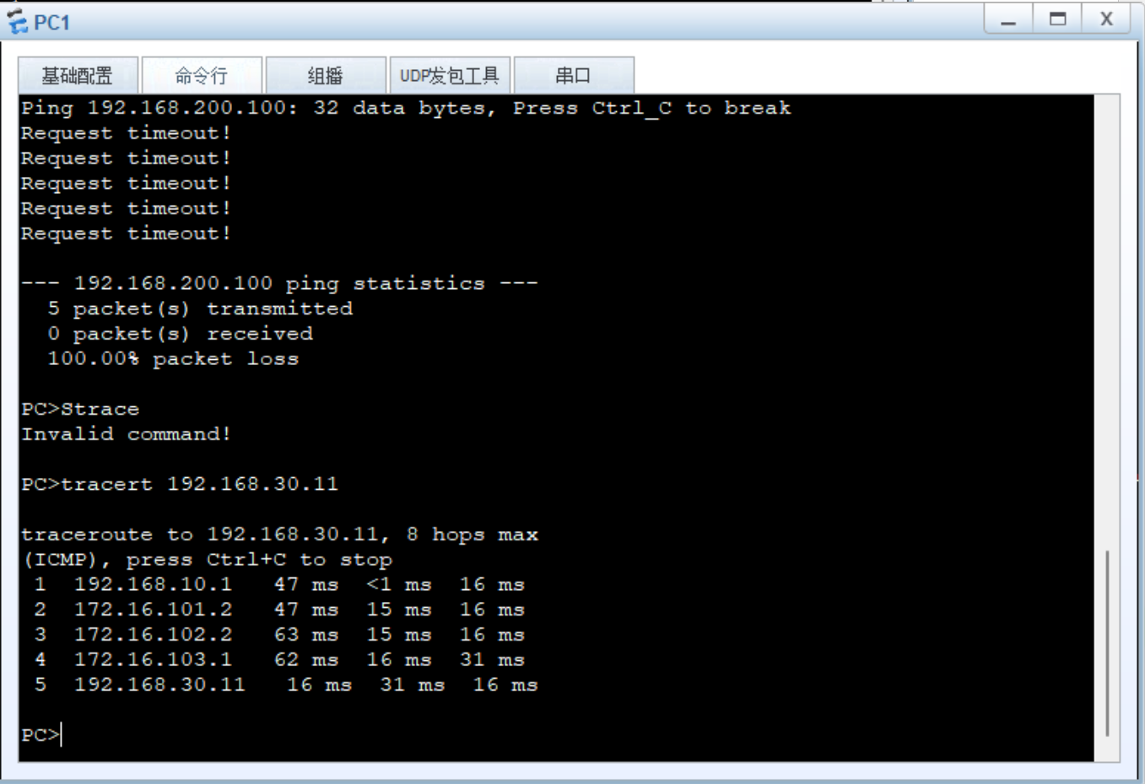

Q4-1.16. Paste the screenshot of the IP routing table on the router RTA.
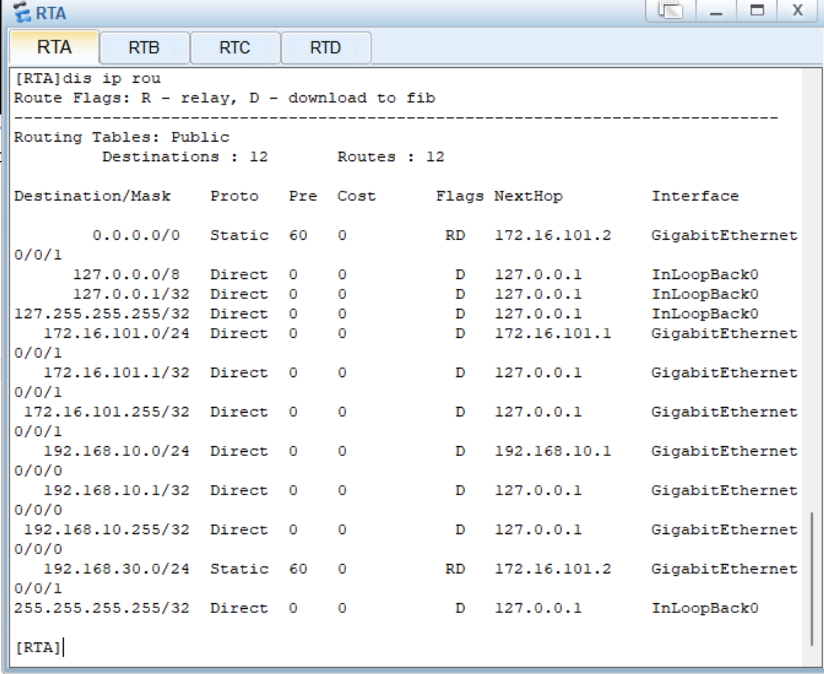

Q4-1.17. Paste the screenshot of the IP routing table on the router RTB.
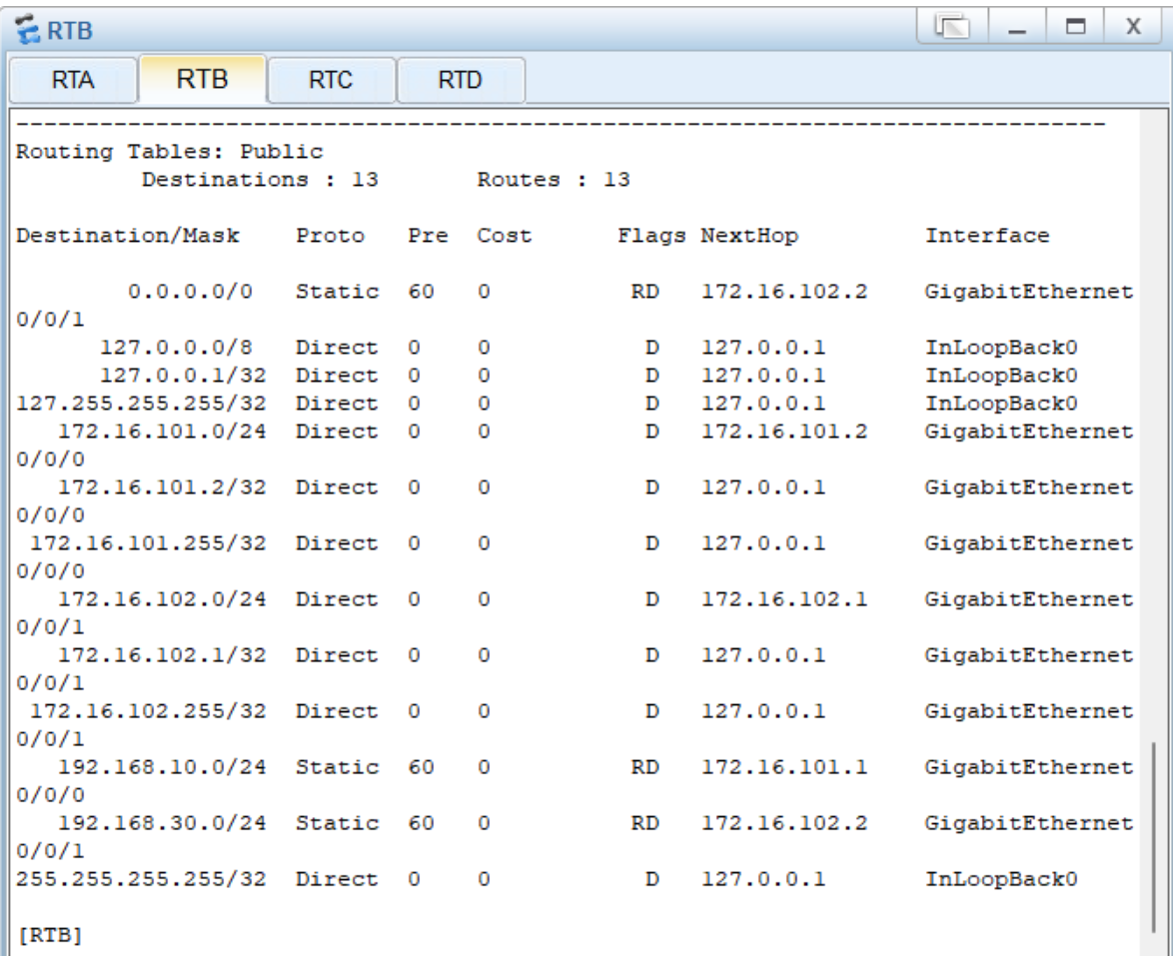
Q4-1.18. Paste the screenshot of the IP routing table on the router RTC.
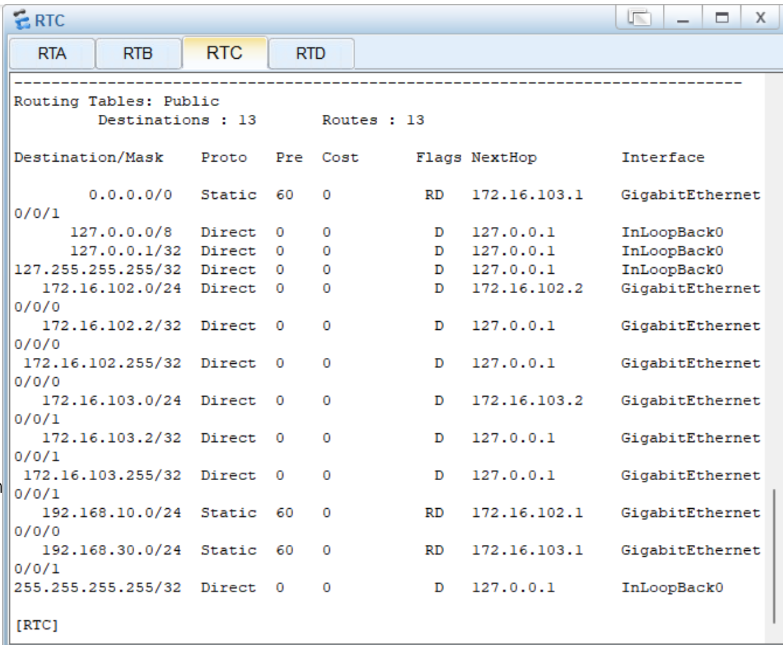

Q4-1.19. Paste the screenshot of the IP routing table on the router RTD.
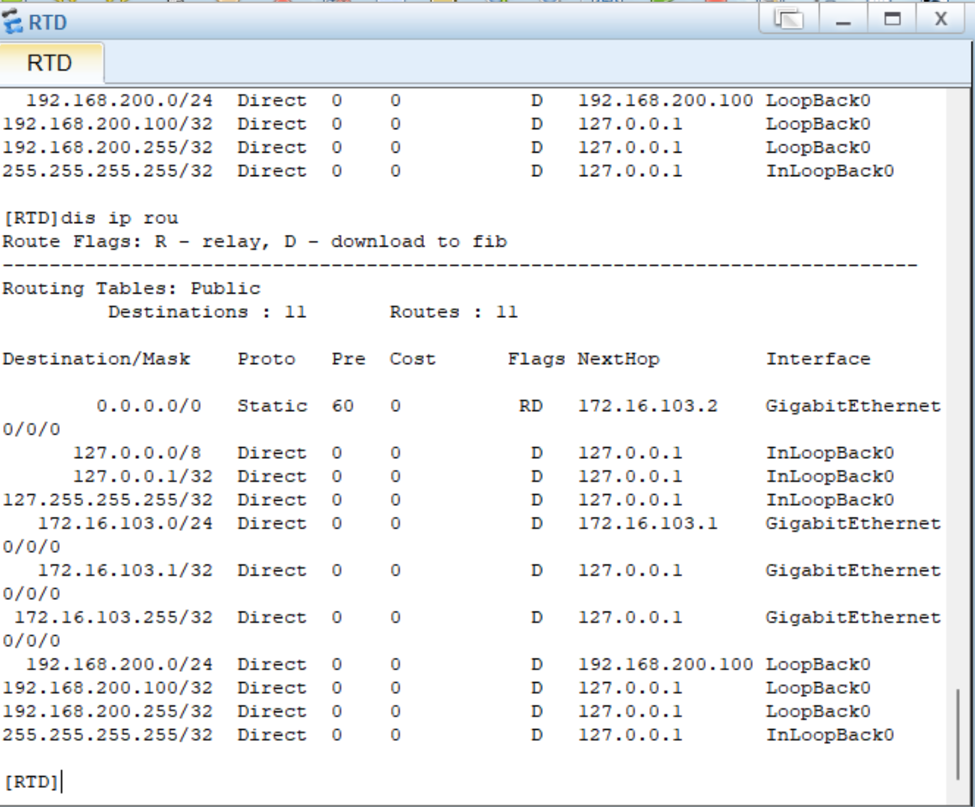
Q4-1.20. Can PC-10-1 and Loopback 0 on RTD ping each other? Please paste the screenshot of the ping result. If they can ping each other, please explain why.
YES, because there is the route.
